What is the change?
Starting in September 2016, the GAINABS website will begin disabling the TLS 1.0 encryption protocol. The disablement of TLS 1.0 TLS ensures that a connection to a remote endpoint is to the intended destination through encryption and endpoint identity verification.
Once TLS 1.0 is disabled on our servers, accessing www.gainabs.org will require your web browser to use the TLS 1.1 or TLS 1.2 encryption protocol.

Why is this happening?
At Chestnut Health Systems, data security/confidentiality is our #1 value, and we take the protection of our customers' data very seriously. The disablement of TLS 1.0 is being undertaken so we can maintain the highest security standards and promote the safety of your data as well as align with industry-wide best practices.
What do I need to do to be prepared for this change?
Internet Browsers
- You and your users will experience issues accessing GAINABS via your browser if non-supported browsers are in use or if you have disabled the supported encryption protocols in the browser.
How to test your browser compatibility
- If you are able to view our test site–which has TLS 1.0/1.1 disabled–without errors, access to GAINABS via your browser should not be impacted by this change, and no action is required.
Action Required for Browser Compatibility
- If you experience errors, you need to ensure your browsers are compatible with TLS 1.2. If your browser is not compatible with TLS 1.2 after we make this change, your users will NOT be able to access GAINABS. We recommend that you begin planning to support TLS 1.2 as soon as possible.

How can find what version of browser I am using?

To determine what version you're running, view the About page for each browser, as outlined in the steps below.

Microsoft Internet Explorer users
To view the About page in Internet Explorer, at the top right of the program window, click the gear icon and select About Internet Explorer in the menu.
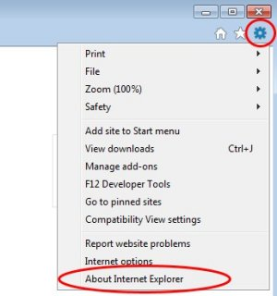
You can also click Help in the menu bar and select About Internet Explorer in the menu.

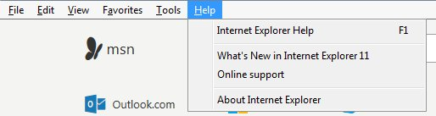
This opens the About Internet Explorer window, where you can view the Versionnumber, as shown in the example below. You can also set Internet Explorer to automatically install new versions when available by checking the box for Install new versions automatically.
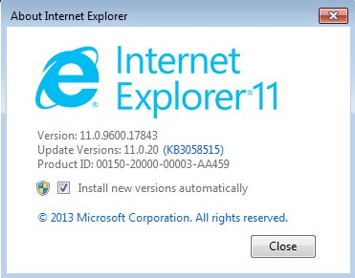

Mozilla Firefox users
At the top right of Mozilla Firefox click the Open menu icon, click the question mark icon at the bottom of the menu, then select About Firefox.
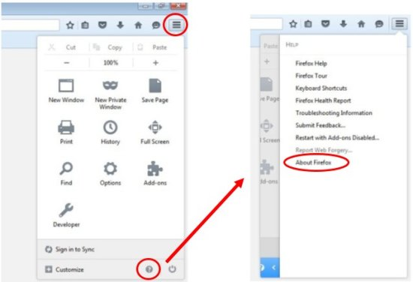
You can also click Help in the menu bar and select About Firefox in the menu.
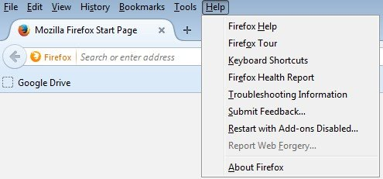
This opens the About Mozilla Firefox window, where you can view the version number, as shown in the example below.
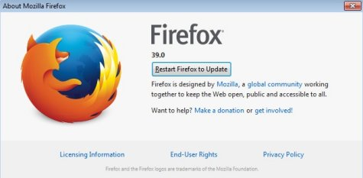

Google Chrome users
Depending on the current version of Google Chrome on your computer, to view the About page, click the Menu icon near the top right corner of the Chrome window (just below the X button that closes the window). In older versions of Chrome, select About Google Chrome in the menu. In newer versions of Chrome, select Help and about, then select About Google Chrome.
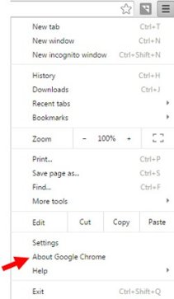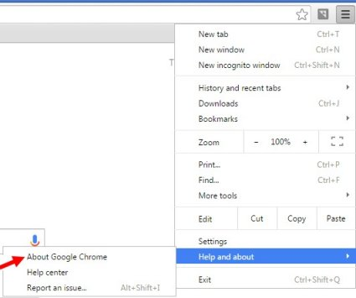
This opens the Chrome About page, where you can view the Version number. Google Chrome will even let you know if your version is up to date.
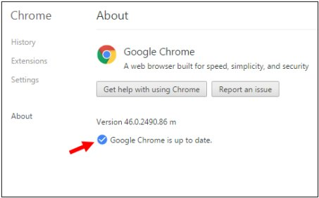

Where can I get the latest version of my browser?
- Chrome - https://www.google.com/chrome/browser/desktop/
- Firefox - https://www.mozilla.org/en-US/firefox/new/
- IE - https://www.microsoft.com/en-us/download/internet-explorer.aspx
- Safari - www.apple.com/safari/

Refer to the compatibility guidelines below:
Browser | Compatibility Notes
Microsoft Internet Explorer (IE)
Review the Enabling TLS 1.1 and TLS 1.2 in Internet Explorer knowledge article for more details.
Desktop and mobile IE version 11 | Compatible with TLS 1.1 or higher by default
Desktop IE versions 8, 9, and 10 | Compatible only when running Windows 7 or newer, but not by default. Review the Enabling TLS 1.1 and TLS 1.2 in Internet Explorer article to enable TLS 1.1 or higher encryption.  Windows Vista, XP and earlier are incompatible and cannot be configured to support TLS 1.1 or TLS 1.2.
Desktop IE versions 7 and below | Not compatible with TLS 1.1 or higher encryption.
Mobile IE versions 10 and below | Not compatible with TLS 1.1 or higher encryption.
Microsoft Edge | Compatible with TLS 1.1 or higher by default.
Mozilla Firefox
Compatible with the most versions, regardless of operating system.
Firefox 27 and higher | Compatible with TLS 1.1 or higher by default.
Firefox 23 to 26 | Compatible, but not by default.  Use about:config to enable TLS 1.1 or TLS 1.2 by updating the security.tls.version.max config value to 2 for TLS 1.1 or 3 for TLS 1.2.
Firefox 22 and below | Not compatible with TLS 1.1 or higher encryption.
Google Chrome
Compatible with the most recent version, regardless of operating system.
Google Chrome 38 and higher | Compatible with TLS 1.1 or higher by default.
Google Chrome 22 to 37 | Compatible when running on Windows XP SP3, Vista, or newer (desktop), OS X 10.6 (Snow Leopard) or newer (desktop), or Android 2.3 (Gingerbread) or newer (mobile).
Google Chrome 21 and below | Not compatible with TLS 1.1 or higher encryption.
Google Android OS Browser
Android 5.0 (Lollipop) and higher | Compatible with TLS 1.1 or higher by default.
Android 4.4 (KitKat) to 4.4.4 | May be compatible with TLS 1.1 or higher. Some devices with Android 4.4.x may not support TLS 1.1 or higher.
Android 4.3 (Jelly Bean) and below | Not compatible with TLS 1.1 or higher encryption.
Apple Safari
Desktop Safari versions 7 and higher for OS X 10.9 (Mavericks) and higher | Compatible with TLS 1.1 or higher by default.
Desktop Safari versions 6 and below for OS X 10.8 (Mountain Lion) and below | Not compatible with TLS 1.1 or higher encryption.
Mobile Safari versions 5 and higher for iOS 5 and higher | Compatible with TLS 1.1 or higher by default.
Mobile Safari for iOS 4 and below | Not compatible with TLS 1.1 or higher encryption.

